5.Sorting & Filtering

Sorting records:
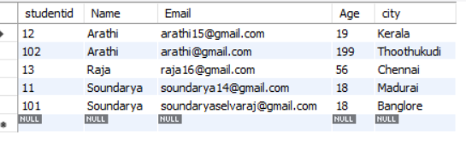
Removing duplicate values:
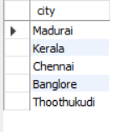
Pattern matching using LIKE:
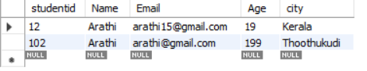
Filtering using IN:
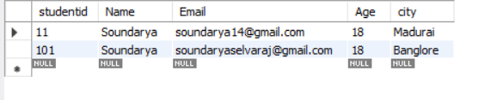
Filtering using between:
